Title of the Paper – Centered, TimesNewRoman Font 24pt, Bold
First A. Author¹, Second B. Author²and Third C. Author¹ (12, bold)
¹University/Company, City, Country (11, regular)
²University/Company, City, Country (11, regular)
Keywords: List of 4-6 important terms describing the main aspect of the paper (font 11).
INTRODUCTION (TITLE OF SECTIONS – ALL CAPS, FONT 11, BOLD)
Submit herein an extended abstract of your paper, following this template. It must be a minimum of 2/3 of one page and not exceed 3 pages. Use the same structure and section headings as a regular paper (e.g. for an experimental paper, Introduction, Methodology, Results, Discussion, Conclusions) to improve readability and clarity. However given that this is an abstract limited to 3 pages, the content will only be a summary. There will probably only be space for an example result. (You are encouraged to submit a full report of your work via a full-length paper for JMPEE - see http://jmpee.org/instructions-submission-manuscripts/)
The INTRODUCTION should be short (1 paragraph), and provide the setting. It should describe the overall issue addressed by the paper, cite one to two of the most important previous works, and define the goal of this specific paper. Refer to publications in the References section by a number in the brackets [1], [2] and follow the suggested format for the referred books and journal papers.
Typographical Instructions: Do not change the page layout (letter paper size, 1.5″ margins), header, or footer. Use the styles defined in the quick style gallery. All styles use TimesNewRoman font. The body text uses normal 11 pt. Do not insert extraneous spaces or blank lines. All symbols, acronyms, and abbreviations must be defined and spelled out the first time they are used in the text. Do not number the pages. Illustrations will be reproduced in full color only the in e-version of the Proceedings. Avoid using light colors (e.g. yellow, light blue) and small symbols/letters/numbers in the graphics.
methOdoloGy
Explain briefly the methods you used to obtain your results. This section might be entitled EXPERIMENTAL APPARATUS AND PROCEDURE, METHODS AND MATERIALS, MODEL ASSUMPTIONS AND DERIVATION OF EQUATIONS, according to your preference and the needs of your paper. Do not focus on particular technical details, but rather describe your method and approach in quite general terms and a clear manner, to help the attendees from other disciplines to grasp the essence of your work. A diagram of your apparatus will help the reader understand what you did. Do not locate diagram in the middle of text paragraphs.
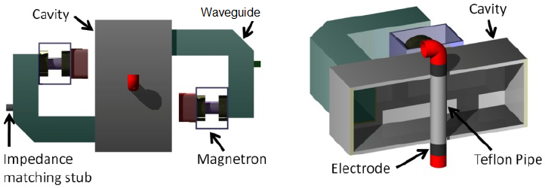
(a) (b)
Figure 1. Schematic diagram of the microwave and ohmic combination heater: upper view (a) and inside view of the combination heater (b) [3]. (use font 10, regular, centered).
RESULTS
Summarize your results, or present an illustrative example of your results. A figure (graph, photograph, etc.) or table usually makes the result more understandable, and interesting. Do not place figures or graph in the middle of paragraphs.

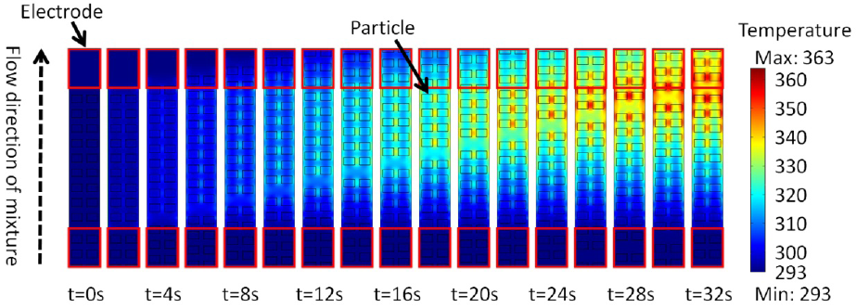
Figure 2. Simulated transient heat pattern of particles during ohmic heating (0.2% NaCl) [3].
DISCUSSION
Briefly explain and your results, and present their implications.
Conclusion
In one or two sentences, state the main point learned from this investigation, e.g. the answer to your research question.
REFERENCES
- R.L. Ramey and T.S. Lewis, Properties of thin metal films at microwave frequencies,J. Appl. Phys., vol. 39, no 2, pp.1747-1752, 1968.
- J.D. Jackson, Classical Electrodynamics, Wiley, N.Y., 1998.
- W. Choi, L.T. Nguyen, S.H. Lee, and S. Jun, Hybrid combination of microwave and ohmic heating technologies for multiphase foods, Proc. 46th IMPI Microwave Power Symp., New Orleans, LA, June 2011, pp. 62-67.

